**Screen Flow :**

* Flows are visual representations of business processes in Salesforce that can be developed and managed using the Salesforce Flow Builder. Flows are intended to automate and streamline complicated business operations such as data collection, record updating, and integration with external systems without the use of code.
* Screen flows are flows that are intended to move users through a sequence of screens in order to collect data or show information. They are commonly used to generate user-friendly data entry forms or wizards with input fields, picklists, and other user interface components.

Steps to create Screen flow

1. Click on Gear icon and select setup, In Quick find Box enter flow and select the flows.
2. Click on New flow and Select Screen flow

3. It will open the canvas. Select (+) and Select the screen element from the drop down.

4. It will open the dialog box. Now give the label name and api name will be auto populated. These labels are for your screen Element.

Label:Candidate info

API Name: Candidate_Info (This field will be auto populated.)

5. In search Component type text and drag the text component to canva and give the label and Api Name

6. Select (+), In search bar search for Create records and select the create records

7. It will open you the details section and give the label as follows:

Label: Create candidate Records

API Name: Create_candidate_Records

Then check the use separate resources and literal values and Search for candidate Object

8. Under field type name and select the name and select the candidate_name under Screen Component. And Click on Done.

9. Click on Save. It will open you details canva and give the details as follows.

Flow label: Candidate flow

Flow API Name: Candidate_flow(this will be auto populated)

10. Click on save and Click on the Activate.

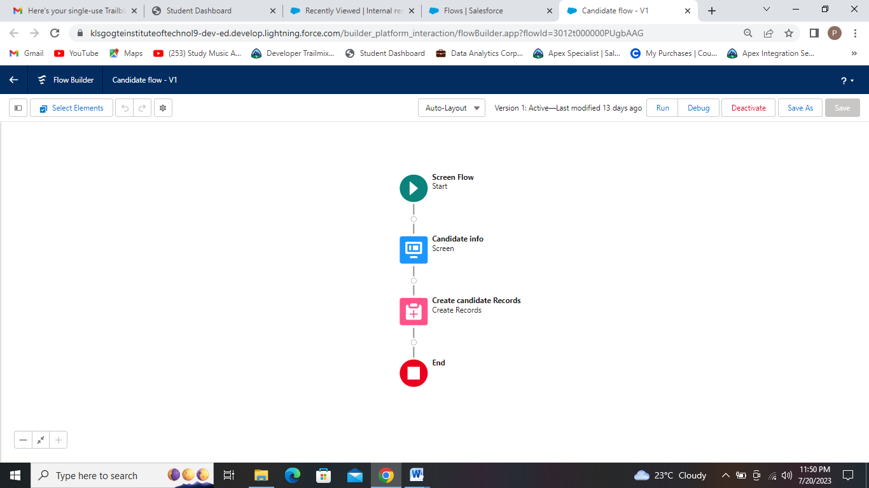

Candidate Flow.

**App Page :**

App page descriptions in Salesforce refer to the metadata and configuration settings that define the visual layout, functionality, and behavior of custom app pages within a Salesforce org. App pages are created using the Salesforce App Builder, which is a visual drag-and-drop tool that allows users to create custom pages without writing code.

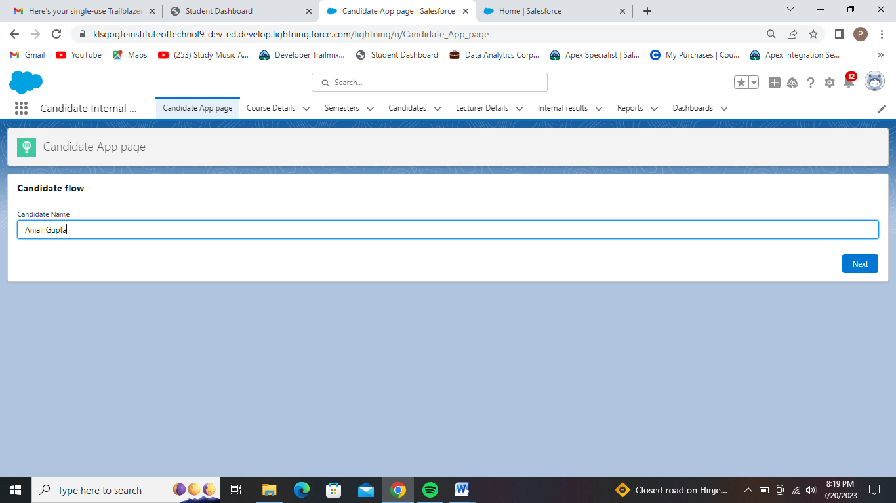

App Page that has Candidate Flow.

* Here we have created Lightning app page for which given a Label as Candidate App page.
* In this page we included Candidate flow component which takes candidates name as input and stores in candidate name field in candidate tab.